# **The “Tailgate Talk” – Before Going to Work**

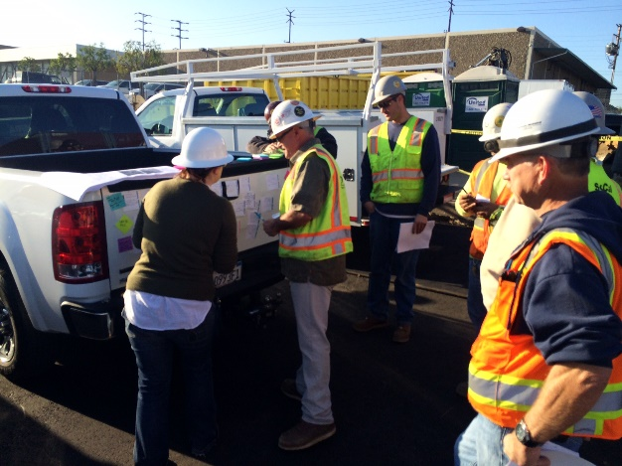Just exactly what is a “tail gate talk”? They are short informational meetings held with employees to discuss a work-site related safety topic. The term tailgate meetings come from the practice of meeting around the tailgate of a pickup truck on site. Tailgate talks (TGT) are used by many state Departments of Transportation, road construction contractors and city and county transportation organizations. If your organization does not, then perhaps it should be considered to be adopted as another front-line defense keeping roadway workers safe.

Image courtesy [www.Paulakers.net](http://www.Paulakers.net) (2014)

## ***What Should Tailgate Talks be About?***

TGTs don’t necessarily have to focus on safety topics; they can also include other important information to roadway workers that ultimately helps provide a safer work environment. Typical TGTs are 5 – 15 minutes to keep everyone’s attention and not get bogged down in details.

Consider the following: You are taking your crew out for a chip seal operation that you will do that day, which is being done entirely by your crew, no outside contractors. You will be setting up the work zone for traffic control, handling the flagging, preparing the road, spraying the emulsion, applying the rock, compacting (if you do this step), sweeping excess rock, and taking down the work zone. That’s a lot of effort and moving parts throughout the day.

Having a TGT with the crew and covering the operation from A – Z is critical communication. All workers need to know what their role is (who is flagging, operating what equipment, etc.); who their designated relief is; how communications occur during the operation (radio, runner, direction by crew leader); etc. For all employees to have a clear understanding of the stages of the work will make the project safer for them and the traveling public.

Perhaps you have covered this extensive project with your crew earlier in the week or the day before; make this TGT a recap to refresh everyone and cover any changes that have just come up.

## ***Tailgate Talk Tips***

* TGTs should not be delivered by the same person day-after-day; change it to keep things fresh and for each crew member to participate and develop their communication skills. Rotate the TGT talk day-to-day or week-to-week.
* Let the crew member who is delivering the TGT pick the topic. Ask them to provide a 1-page handout for each crew member that highlights the issues.
* Have everyone stand to keep focus and keep the meeting short. Circling the presenter is a good approach.
* Hold the meeting at the same time (preferably at the tailgate!) each day. Ensure it is part of the routine.
* Choose a topic that applies to those working. This may include near misses of workers in a work zone that occurred recently, what equipment may come into the work zone, etc.
* Encourage employee participation. Don't just talk . . . encourage all to ask questions.
* Keep it short, direct, and personal.

Remember – use all of the other TxLTAP Tailgate Talk documents that are available to you!